Self-Managed Event
Central Park – Havering

Game Information Sheet
Name | London Youth Games Foundation
Date of Event | 27/03/2017
Game valid from… | 00:01 on 27/03/2017
Game valid to… | 23:59 on 27/03/2017
Location | Central Park - Havering
Event Theme | Easter
Number of Teams
Technical Support | Any questions on the day please call: 0845 8382402 for further support. We are always on call.
Briefing Video | Click this link to watch a how to video for your event
Notes

Live Game QR Code

QR Code: | Game Code:  743259091085
 | Once you have loaded the ‘Mobile Adventures’ App onto your device, simply open the App and scan your game QR Code or enter the game code to load the game.

Your location

The map below outlines the area where your event will be take place. Please Note: The challenges can be completed in any order. This map is a rough outline of the area your game will be. Hotspots may vary.

Start & Finish Locations

You can start and finish your game anywhere you would like in the area, although we would recommend that it is in a location/venue that is central to where your game is based as this will allow the teams to disperse in different directions rather than follow one another!

Remember that you should plan for your game to last up to 2 hours! Please ensure that your device is fully charged prior to starting the game!

Introduction to the “Mobile Adventures” App

Our Mobile Adventure App provides Teams with a unique and interesting way to explore a location. We have designed our games to take players to some interesting parts of the city on foot to discover new things, learn interesting facts and have fun!

Objective of the Game

The aim of the game is for teams to navigate around the chosen location using the Mobile Adventures App and to complete as many tasks and challenges as possible to earn the most points. Teams will have to physically visit the hotspots in order to unlock the challenges using GPS activation.

Pre-Event Preparation – Requirements

Before you load the app please note the following:
- You should plan for your game to last up to 2 hours.
- Please ensure that your devices are fully charged prior to starting the game!
- Minimum Requirements – For the app to work on your device, it must be running on iOS v9.0 or above and Android v4.4 or above. This can be checked by accessing the ‘About Device’ details in your devices’ General Settings. Please see the “Recommended Device List” below.
- Your device must have GPS and Data in order to play the game!
- Players will need to have a data plan or be connected to Wifi to download the Mobile Adventures App.
- During the game, players will need data to operate the map and for the updating of the live scoreboard feature. If you are using an Android device, please ensure you have the latest version of Google Maps on your device.
- You must have sufficient memory on your device to hold photos & videos.

Recommended Device List

- IOS devices from the iPhone 5 operating system 9.0 and above
- Android devices from operating system 4.4 (Kitkat) and above
- All Tablet devices used during the game must be set up with a sim card and have an activated data package.
- For more details go to: https://wearewildgoose.com/team-events/recommended-devices/

All Tablet devices used during the game must be set up with a sim card and have an activated data package.

Please note: The app will not work on Windows phones or Blackberry.

24 hours prior to the event - download the App….

Step 1: Download the App
The Mobile Adventures app can be found by searching ‘Mobile Adventures’ on the Google Play Store or ‘Mobile Adventures – Team Treasure Hunts’ on the iOS App Store.

If you cannot find the App make sure that your device is running the minimum system required (Refer to the “Pre-event preparation” section). Please advise two members of each team to download the App to their phone using Wifi before the event date!

Step 2: Load the Game

To load the game, open the App on your device and scan the QR Code provided with your game instructions. Alternatively you can manually enter the Game Code into the relevant box to start loading the game.

Please note that the time it takes to load the game will vary depending on your device and the Data/Wifi signal. We would always suggest where possible that the game is loaded using a Wifi connection- do not forget to switch the Wifi off once the game has finished loading. You will see a notification at the bottom of the screen when the game has completely loaded. At this stage, you are then able to exit the app until you are ready to play!

On the day - checklist

- Android devices - make sure that you have the latest version of Google Maps installed and that you have approved the relevant terms to use the App.
- Ensure that you have turned on GPS and Data on your device.
- Once the game is loaded, please make sure Wi-Fi is switched off on your device for the duration of your game so your device can communicate with our server via mobile data at all times.
- Ensure your device is fully charged – no power, no play!! To save battery life, it is advised you close all other apps running in the background.
- Pre-load the app on a minimum of 2 devices per team so the game can be continued if the starting device runs out of battery!

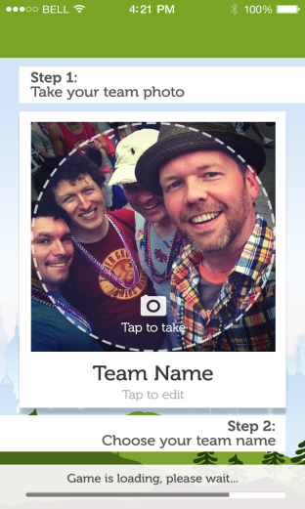
On the day - How to Play the Game

Step 1: Take a Selfie and give yourself a team name!

When all teams have loaded the game, the “Join Game” screen will appear and each team will need to take a ‘selfie’ and come up with a team name. Your photo and team name will appear on the live scoreboard and will be visible to other teams as your team marker on the map, so make it memorable! Make sure that all teams know where you are finishing and the finish time. When you are ready to start get all teams to hit the ‘Join Game’ button and you are off!

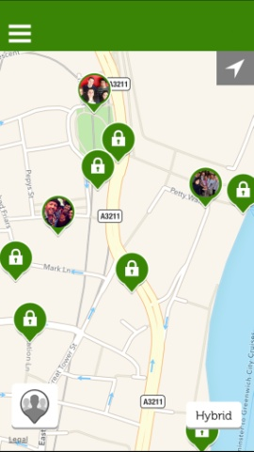
Step 2: Visit the GPS “Hotspots”
The green icons on the map are what we call GPS “Hotspots” and you are able to see from the padlock that they are all locked at the beginning. The team will need to visit those padlocked hotspots; when the GPS picks up that you are in that hotspot, it will unlock tasks to complete.
Each hotspot will activate a Task Group- this will include a range of challenges including General Knowledge questions, Location Specific questions or Fun Photo/Video Challenges. To find your tasks, tap on the hamburger menu icon (three lines in the top left hand corner) and select tasks.

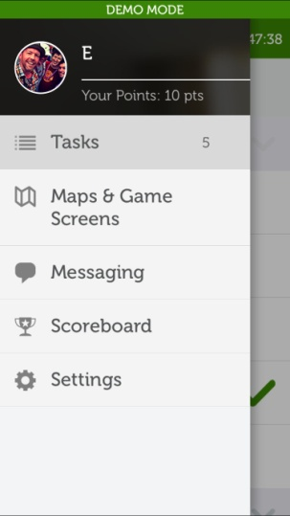

Step 3: Complete Tasks and Challenges

Your unlocked tasks will appear under the Tasks tab for you to complete. Simply tap on the tasks to access them; then follow the on-screen instructions to complete the question. Please note: You may need to scroll down on the screen to view the whole question!
All photos and videos will be saved onto the team’s device so they can be viewed later. You will need some memory space in order to house them. These photos and videos are taken through the app using the phone’s camera, so teams will not need to exit the App to take the photos and videos.

Step 4: Identify the Winning Team

Once all teams have completed the game and have returned to the agreed finish location (at the agreed time!), scores can be compared on the live scoreboard to see who has won! Don’t forget to share your photos with the other teams – they can be found in the photo folder on your device.

FAQ’s

I can’t find the App?

You will be able to find the app on the App Store by searching for “Mobile Adventures”. The app only works on Android phones/tablets and iPhone’s and iPad’s. The app will not work on Windows phones or Blackberry phones. There are also minimum versions the operating system that are required for the app to be compatible - please refer to the “Pre Event Preparation” and the “Recommended Device List” sections earlier in the document for more information.

I have downloaded the app and scanned the QR Code, but the game is not loading?

In this situation, please check the following:
- Data must be switched on! You will need a data connection either through a sim card or Wifi in order to load the game. If you do have a data connection, check the signal strength; in areas where signal strength is weak, the game may take longer to load. Be patient!

- Google Maps: On Android phones, the App requires an up-to-date version of Google Maps so please ensure the latest version is installed as well as agreeing to the terms and conditions.

- Check that your game hasn’t expired - the date your game is valid for can be found on the “Game Information” page.

- Try to input the Game Code (12 digit code located on the Live Game QR Code section) instead of scanning the QR Code.

- The server may be undertaking maintenance on the system or the game. Please wait 10 minutes and then try again.

- Try “hard closing” and re-opening the app. This is when you close the app down from the background.

- There might be a problem with the device itself and therefore we would recommend trying to play on another device.

- If all of the above fails, then call us further support on 0845 8382401. You can reach us on this number 24 hours a day!

What happens if my device runs out of battery?
You can avoid the device running out of battery by reducing the screen brightness. Alternatively, you can use the “Rejoin Pin” to continue your game on another device.
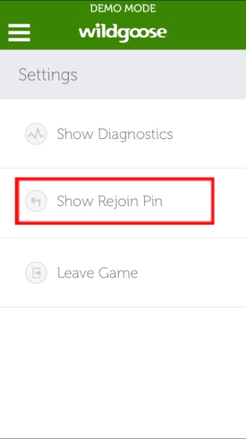
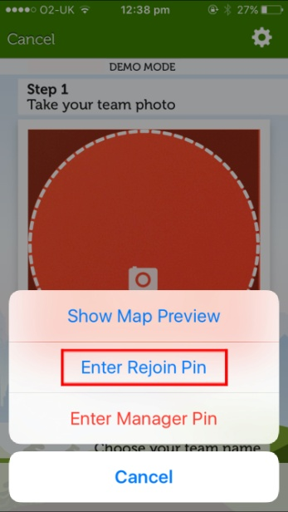
Rejoin pin allows you to transfer your game mid-flow onto another device. You will be able to continue where you finished off and all your points will automatically be transferred to the new device. Don’t join as another team otherwise your progress will not be saved!
The game must be fully loaded before the rejoin pin option appears.
Simply access your Rejoin pin via the settings menu > Show Rejoin Pin. Enter this pin on the new device by tapping on the cog in the top right corner of the screen and enter rejoin pin. You can now continue to play the game on the new device!

I have reached the location of a padlocked hotspot icon but it will not unlock?
Please zoom in on the map to ensure you are in the right location. Make sure your GPS is turned on - your location will show as a dot on the map! If the hotspot still won’t unlock then please call us for support and we can remotely unlock the hotspot to release the challenges for you.

How much data will the game use?
The app is about 20-30MB in size and the game will be between 15-20MB to load depending on your chosen game location. During the game, your device will use approximately 25MB of data.

How far will I walk?
Approximately 3-4 kilometres (2-3 miles). The route teams take can vary depending on which order they complete the hotspots in and how many they complete therefore these distances may vary and are for guidance only.

How long will I be playing the game for?
It is difficult to determine the exact duration of the game as there’s plenty to stop and see along the way! However, we would recommend that you plan to be out and about for a maximum of 2 hours.

Where are my photos and videos?
All photos and videos taken during the event can be found in the usual photo folder/app on the device used to play the game. Why not arrange to meet up after the game has finished to share these with the other teams?

Important Safety Information
This event has been Risk Assessed and is considered to be a low risk activity.
However, all participants must be aware that they take part at their own risk. We accept no responsibility or liability for any claim, loss, damage, injury or inconvenience sustained or caused as a result of using this product. By taking part, you and anyone accompanying you agrees to do so entirely at your own risk.
The following will help you to run a safe event:
- Always check the weather forecast and Met Office weather warnings before your event and do not venture out if any severe weather has been forecasted.
- Make sure you dress appropriately for the weather!
- Think about the participants - if you have a mixture of ages and abilities, pregnant women or those with injuries you may wish to plan a rest stop during the event.
- Traffic- be aware of your surroundings and please cross the roads safely.
- Ensure that every team member has the organisers contact number.
- In the event of any serious accidents or injuries, please call the Emergency Services- in the UK, they can be contacted on 999.

